ORTHOPAEDIC INSTRUMENTS
Instruments for Titanium Elastic Nails
Awl for Elastic Nail
Intended Use
The awl for elastic nail is used to create the cortical entry portal for titanium elastic nail (TEN) insertion in paediatric and small animal long bone fractures. It perforates the cortex at the pre-planned entry point, initiating a channel that guides the nail into the medullary canal for flexible intramedullary fixation. | 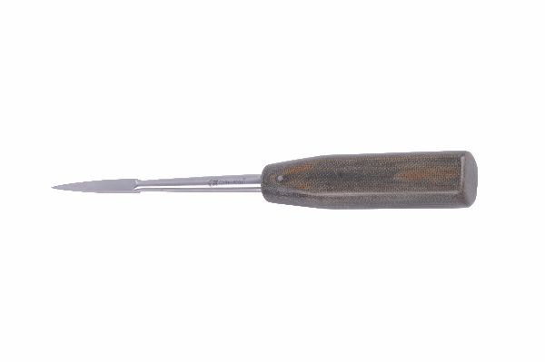
Function
A sharp, bevelled or trocar-tipped point is driven through the cortex by hand or mallet strikes on the handle. The conical body widens the portal to the nail diameter as it advances, creating a smooth, accurately sized hole that accepts the elastic nail without cortical splitting or uncontrolled crack propagation.
Advantages
Controlled Cortical Entry: The awl creates a precise entry portal exactly where the surgeon marks, preventing the lateral drift that a drill can experience on curved cortical surfaces, which would misalign the nail's intramedullary trajectory.
Minimal Thermal Damage: Hand-driven penetration generates no frictional heat, protecting the periosteum and endosteum at the entry site from thermal necrosis that compromises the biologic environment needed for rapid paediatric fracture healing.
FAQ
Q: What entry point is used for femoral TEN insertion?
A: The distal femoral metaphysis, approximately 1.5 cm proximal to the physis, is the standard anteromedial and anterolateral dual entry for TEN fixation of femoral shaft fractures in young dogs and children.
Q: Can the awl be used without a mallet?
A: In thin cortex of young patients the awl can be hand-pushed; in denser cortex a mallet provides controlled impaction force — avoid rotational pressure which risks tip breakage.

ORTHOPAEDIC INSTRUMENTS
Instruments for Titanium Elastic Nails
Beveled Tamp
Intended Use
The beveled tamp is a directional impaction instrument used to advance and steer the bent tip of a titanium elastic nail within the medullary canal during fracture reduction and TEN fixation. Its angled face allows fine directional corrections when the nail tip needs re-directing toward the fracture site. | 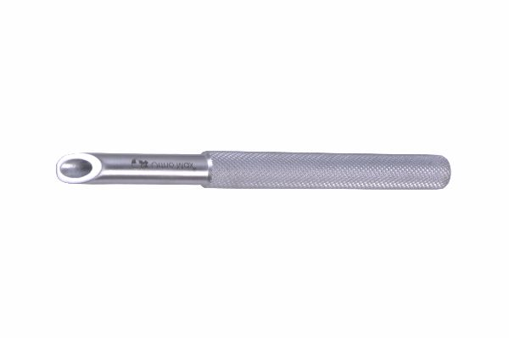
Function
The beveled distal face contacts the nail's curved tip at an oblique angle. When struck with a hammer, the angled impact deflects the nail tip in a controlled direction determined by the bevel orientation. Rotating the tamp handle reorients the bevel, allowing three-dimensional steering of the nail through the canal.
Advantages
Directional Nail Steering: The angled working face converts axial mallet force into a lateral deflection force at the nail tip, enabling the surgeon to navigate around medullary canal curves and guide the nail across the fracture site without cortical breach.
Prevents Nail Buckling: Controlled impaction through the tamp body protects the nail from kinking during advancement through curved canals — a critical advantage when inserting nails of borderline diameter relative to the canal width.
FAQ
Q: How is bevel direction controlled during nail insertion?
A: The surgeon notes the bevel face orientation marked on the tamp handle and rotates the instrument before each mallet strike to direct deflection force toward the desired steering direction.
Q: What nail diameters is the beveled tamp used with?
A: Beveled tamps are used with TEN sizes from 2.0 mm to 4.0 mm; separate tamp sizes are available to match each nail diameter and provide full-face contact during impaction.

ORTHOPAEDIC INSTRUMENTS
Instruments for Titanium Elastic Nails
Container for Elastic Nails
Intended Use
The container for elastic nails is a sterile storage and transport tray used to organise titanium elastic nails by diameter and length within the operating theatre. It protects the nails from mechanical damage and contamination during surgical set-up and facilitates rapid nail selection during fracture fixation procedures. | 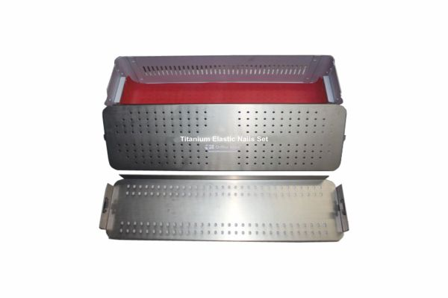
Function
Individual slots or tubes in the container body hold each nail separately, preventing contact between nails that would cause surface scratches. Size markings on each slot allow the scrub nurse to confirm nail diameter and length before passing to the surgeon, reducing intraoperative selection errors.
Advantages
Implant Protection: Individual compartments prevent titanium elastic nails from contacting each other, eliminating surface scratches that can act as stress-riser initiation sites reducing the nail's cyclic fatigue endurance under dynamic load in active patients.
Rapid Intraoperative Selection: Clearly labelled slots allow the scrub nurse to locate and confirm the correct nail size within seconds, avoiding the delay of identifying nails by visual inspection of similar-looking implants during time-critical fracture fixation.
FAQ
Q: Can the container be autoclaved with the nails inside?
A: Yes — the container and its nails are sterilised together as a unit, maintaining organisation through the sterilisation process and preventing mixing with other instrument sets during hospital processing.
Q: How are nails selected for TEN fixation?
A: Nail diameter is chosen as 30–40% of the narrowest medullary canal diameter on radiographs; two nails of equal diameter are inserted from opposite sides for symmetric three-point fixation.

ORTHOPAEDIC INSTRUMENTS
Instruments for Titanium Elastic Nails
Extractor Rod
Intended Use
The extractor rod is a nail removal instrument used to pull titanium elastic nails out of the medullary canal after fracture healing. It threads into or hooks onto the nail's proximal end, allowing controlled extraction without damaging the healed bone or the implant during removal. | 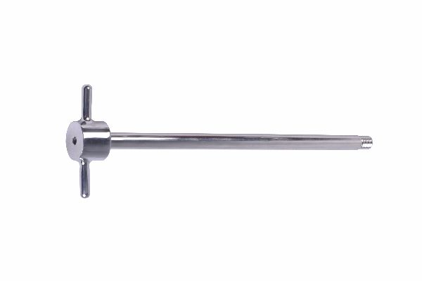
Function
A threaded or hook tip engages the nail's extraction eye or proximal end. The rod provides a solid purchase point through which the surgeon applies steady extraction force, either by hand pulling or by using a slotted hammer over the rod shaft for impactive extraction when the nail is firmly embedded.
Advantages
Controlled Nail Removal: Engagement with the nail's proximal end prevents slippage during extraction, allowing steady progressive force application that loosens the nail from any fibrous tissue ingrowth without the sudden uncontrolled movement that could fracture healed bone.
Hammer-Assisted Extraction: Compatibility with the slotted extraction hammer allows impactive reversal force when manual traction alone cannot overcome nail-to-bone bonding, making removal reliable even in cases with prolonged implant residence time.
FAQ
Q: When are elastic nails typically removed?
A: Nails are usually removed 3–6 months after surgery once radiographic healing is confirmed; earlier removal risks refracture, while very late removal increases adhesion complexity.
Q: What if the nail extraction eye is bent or damaged?
A: The nail end must be exposed by enlarging the entry portal, then gripped with extraction pliers or the slotted hammer system; a damaged eye does not prevent removal but requires a different instrument approach.

ORTHOPAEDIC INSTRUMENTS
Instruments for Titanium Elastic Nails
F Tool
Intended Use
The F tool is a specialised bending instrument used to pre-bend titanium elastic nails to the correct curvature before insertion. The precise pre-bend is essential for elastic nail technique because the nail's stored spring energy provides the three-point fixation that stabilises the fracture fragment during healing. | 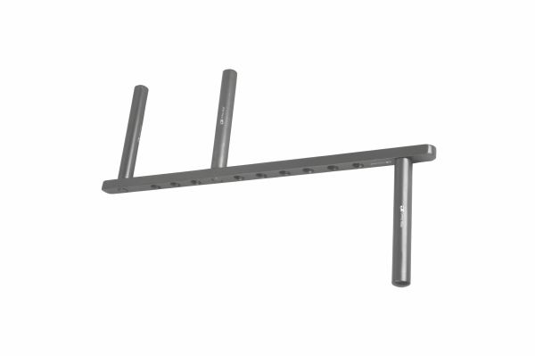
Function
The F-shaped instrument body accepts the nail in a defined slot and uses the two outer prongs as a fixed fulcrum while the central prong applies the bending force. By repositioning the nail along the slot, the surgeon creates a smooth, reproducible curve of calculated radius matched to the patient's medullary canal diameter.
Advantages
Reproducible Pre-Bend Geometry: The F tool's fixed prong geometry produces a smooth, consistent curve without the flat spots or kinks that free-hand bending creates, ensuring the nail's spring-back force is evenly distributed along the medullary canal wall for reliable three-point fixation.
Prevents Metal Fatigue: Controlled bending through the F tool distributes deformation stress over the full bending radius, preventing localised cold-working that reduces the nail's fatigue endurance under repetitive loading during fracture healing.
FAQ
Q: How much pre-bend is required for TEN fixation?
A: The standard pre-bend height equals approximately 3 times the nail diameter; this creates a stored spring energy that produces adequate three-point cortical contact throughout the fracture zone.
Q: Can the F tool bend both stainless steel and titanium nails?
A: The F tool works with both materials but the bend geometry differs; titanium springs back more than steel, requiring slightly greater over-bending to achieve the desired final radius.

ORTHOPAEDIC INSTRUMENTS
Instruments for Titanium Elastic Nails
Hammer SS Handle Big
Intended Use
The stainless steel handled hammer is the primary impaction instrument used to drive elastic nails through the cortical entry portal and advance them along the medullary canal during TEN fixation. The large head provides controlled impact force appropriate for advancing nails in medium and large animal bones. | 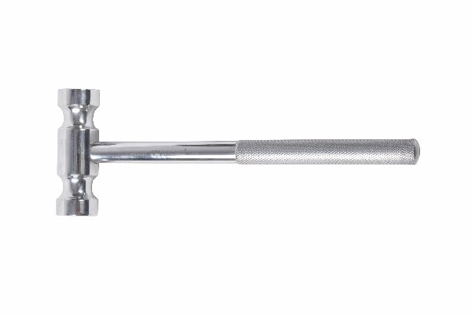
Function
A precision-balanced stainless steel head mounted on a solid SS handle delivers repeatable impact energy per strike. The surgeon directs blows onto the tamp or directly onto the nail introducer, advancing the nail in controlled increments through the medullary canal while tactile feedback through the handle signals changes in resistance.
Advantages
Balanced Impact Control: The weight-balanced SS head delivers consistent force per strike, preventing the erratic impaction that results from an unbalanced hammer — critical for controlled nail advancement in the thin medullary canals of small and medium breed dogs.
Full Autoclave Compatibility: All-stainless construction withstands unlimited 134°C sterilisation cycles without handle deterioration, maintaining sterile instrument availability for emergency fracture cases in busy small animal surgical facilities.
FAQ
Q: How hard should hammer strikes be during nail insertion?
A: Moderate, controlled strikes are preferred — heavy blows risk cortical shattering; if the nail does not advance with moderate force, re-evaluate nail diameter or entry portal position rather than increasing impact force.
Q: When is the big hammer used versus a standard sized one?
A: The big hammer is used for nails ≥3.0 mm in medium and large breed dogs; smaller hammers are used for 2.0–2.5 mm nails in cats and toy breeds where lighter, more precise impacts are required.

ORTHOPAEDIC INSTRUMENTS
Instruments for Titanium Elastic Nails
Locking Plier for Elastic Nail
Intended Use
The locking plier for elastic nails is used to grip and bend the protruding nail end after insertion, creating the hook or fold that prevents the nail from migrating proximally out of the medullary canal during the postoperative period. This final step secures the nail position until fracture healing is complete. | 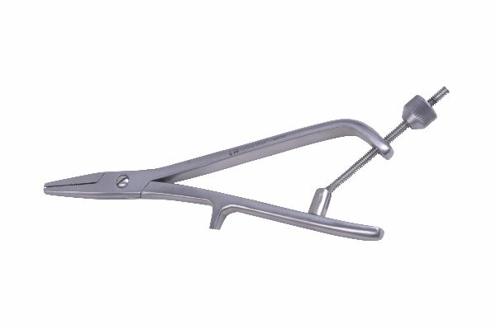
Function
The plier jaws grip the nail immediately at the cortical entry portal. A ratchet locking mechanism holds the grip while the surgeon applies bending force to fold the protruding nail end back against the bone surface. The bent end forms a mechanical stop that prevents proximal nail migration under functional loading.
Advantages
Prevents Nail Migration: The fold created by the locking plier provides a positive mechanical stop against the bone cortex, preventing the proximal nail migration that causes soft tissue irritation and requires early revision surgery before fracture healing is complete.
Controlled Bend Without Nail Damage: The wide jaw face distributes bending force over the nail cross-section, preventing the notch formation that a narrow-jaw plier would create — notches reduce nail fatigue endurance and increase fracture risk at the bend point.
FAQ
Q: How much nail is left protruding after folding?
A: The nail end should protrude 1–2 cm above the cortex before folding; too little length makes future extraction difficult, while too much causes prominent soft tissue irritation.
Q: Is nail trimming needed before folding?
A: Yes — nail cutters trim the nail to the correct protrusion length before the locking plier creates the fold; the cut end should be smooth to prevent skin irritation through the subcutaneous tissue.

ORTHOPAEDIC INSTRUMENTS
Instruments for Titanium Elastic Nails
Slotted Hammer
Intended Use
The slotted hammer is an impactive extraction instrument used to remove titanium elastic nails at implant retrieval surgery. Its longitudinal slot fits over the extraction rod, allowing the hammer's weight to be driven against a fixed stop, generating controlled reverse impaction force to loosen and extract the nail from the medullary canal. | 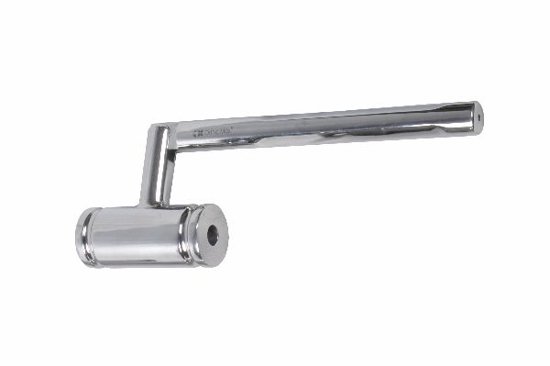
Function
The slot in the hammer body accommodates the extractor rod shaft. When slid forcefully along the rod and stopped by a shoulder or collar, the kinetic energy of the hammer mass transfers as an extraction impulse through the rod into the nail, progressively loosening the nail from any fibrous tissue attachment within the canal.
Advantages
Impactive Reversal Force: The sliding hammer mechanism multiplies extraction force beyond what manual traction can achieve, making removal reliable even when titanium elastic nails have been in situ for extended periods with significant fibrous tissue ingrowth around the nail body.
Protected Rod During Extraction: The slot prevents lateral bending moments on the extractor rod during impaction, protecting it from fatigue fracture — a critical safety feature given that a broken extractor rod inside the canal requires complex retrieval surgery.
FAQ
Q: How many hammer strikes are typically needed for nail extraction?
A: Most nails release within 5–15 moderate strikes; if resistance is extreme, the nail can be partially rotated first to break fibrous adhesion before continued impaction extraction.
Q: Can the slotted hammer be used for plate screw extraction?
A: No — the slotted hammer is specific to the TEN extractor rod system; plate screw extraction requires a dedicated screw extractor or broken screw removal forceps.

ORTHOPAEDIC INSTRUMENTS
Instruments for Titanium Elastic Nails
Standard Tamp 2–2.5mm
Intended Use
The standard tamp for 2–2.5 mm elastic nails is an axial impaction instrument used to advance small-diameter titanium elastic nails through the medullary canal in cats and toy/small breed dogs. The tamp diameter matches the nail, transmitting mallet force directly along the nail axis for controlled advancement. | 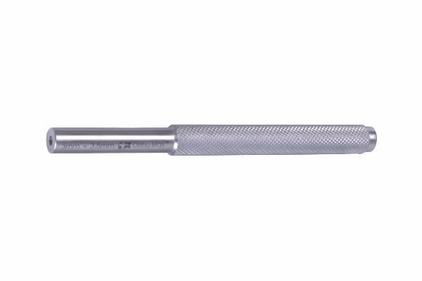
Function
A hollow or solid tip seats over or against the nail's proximal end. Mallet strikes on the tamp handle drive it axially, transmitting force along the nail length to advance it through the canal. The matched diameter prevents eccentric loading that would buckle or kink thin elastic nails during insertion.
Advantages
Size-Matched Force Transmission: Exact diameter matching between tamp and nail ensures the impaction force is centred on the nail axis, preventing the lateral bending moments that would kink a 2.0 mm nail when driven with a tamp of mismatched size.
Essential for Feline Cases: Small animal TEN fixation in cats and toy breeds requires precise, low-force impaction that this size-appropriate tamp enables — larger tamps contact the nail off-centre and risk canal wall damage in the narrow medullary spaces of small patients.
FAQ
Q: What fractures are treated with 2–2.5 mm elastic nails?
A: Femoral and tibial shaft fractures in cats and small dogs (body weight 2–10 kg), radial and ulnar fractures in medium breeds, and metacarpal/metatarsal fractures in larger dogs typically use 2.0–2.5 mm diameter nails.
Q: Can I use a 3 mm tamp on a 2 mm nail?
A: No — the oversized tamp contacts the nail at its edges rather than face-on, concentrating force and causing kinking; always use the size-matched tamp.

ORTHOPAEDIC INSTRUMENTS
Instruments for Titanium Elastic Nails
Standard Tamp 3–3.5mm
Intended Use
The standard tamp for 3–3.5 mm elastic nails is used to advance medium-diameter TEN implants in medium breed dogs undergoing femoral, tibial or humeral shaft fracture repair. The intermediate size bridges the gap between the small-patient 2.5 mm and the large-patient 4 mm tamp, covering the most common size range in small animal TEN practice. | 
Function
A solid, precision-machined tip matched to 3.0–3.5 mm nail diameter is driven onto the nail end with mallet strikes. The tip geometry centres the force on the nail's cross-sectional axis, advancing the nail steadily through the medullary canal while the handle length provides adequate leverage for controlled impaction without excessive wrist force.
Advantages
Most Frequently Used Size: The 3–3.5 mm range covers the majority of canine TEN cases in medium breeds (10–25 kg body weight); having a dedicated size-matched tamp for this range ensures optimal nail advancement without cross-size compromise in everyday surgical practice.
Ergonomic Impaction Handle: The handle length and grip profile are optimised for the moderate mallet forces needed with 3.0–3.5 mm nails, reducing surgeon hand fatigue during multi-nail insertion procedures such as bilateral femoral fixation.
FAQ
Q: How is the 3–3.5 mm nail size selected?
A: Measure the narrowest medullary canal diameter on the craniocaudal radiograph and multiply by 0.35; for a 9 mm canal the appropriate nail is 3.0–3.2 mm diameter.
Q: Is the tamp reused or single-use?
A: The stainless steel tamp is a reusable instrument; inspect the tip for deformation after each case, as a flared or mushroomed tip concentrates force at the nail rim and should be replaced.

ORTHOPAEDIC INSTRUMENTS
Instruments for Titanium Elastic Nails
Standard Tamp 4mm
Intended Use
The standard tamp for 4 mm elastic nails is the largest size used in TEN fixation, designed for large breed dogs undergoing femoral or tibial shaft fracture repair where the medullary canal accommodates 4 mm diameter nails. The heavy-duty tamp transmits the greater impaction energy needed to advance a 4 mm nail through dense cortical bone. | 
Function
A robust, solid stainless steel tip precisely matched to 4 mm nail diameter is impacted with a large mallet. The tamp body and handle are dimensioned for the higher impact forces required, transmitting energy efficiently into the nail without energy loss from flex or rebound in the instrument shaft.
Advantages
Heavy-Duty Construction: The 4 mm tamp's increased wall thickness and reinforced tip withstand the repeated high-force mallet strikes needed to advance 4 mm nails through large-breed canine cortical bone, maintaining tip geometry accuracy throughout the insertion procedure.
Large Breed Fracture Coverage: Providing a dedicated 4 mm tamp expands TEN fixation capability to large breed femoral shaft fractures (25–40 kg), where 4 mm nails provide adequate stiffness and spring-back force for reliable three-point fixation.
FAQ
Q: What is the maximum recommended nail diameter for TEN fixation?
A: Most TEN systems are used with nails up to 4.0 mm; above this diameter the nails become too rigid, losing the elastic flexibility that enables the three-point fixation mechanism fundamental to TEN technique.
Q: Is a 4 mm nail appropriate for all large breeds?
A: Nail size depends on canal diameter not body weight; always measure the narrowest canal point radiographically — some compact large breeds have narrower canals requiring smaller nails than expected.

